FA5
Joseph Raphael M. Espiritu, Harneyyer Clores
knitr::opts_chunk$set(echo = TRUE)

Problem 8.17 – Mean and Variance of X
Midwestern University has 1/3 of its students taking 9 credit hours, 1/3 taking 12 credit hours, and 1/3 taking 15 credit hours.
We define $X$ as the number of credit hours.
Thus, the probability distribution is:
X | p(X)
9 | 1/3
12 | 1/3
15 | 1/3
The mean and variance are calculated as follows:
$$μ_{X}=∑Xp\left(X\right)=9\left(1/3\right)+12\left(1/3\right)+15\left(1/3\right)=12$$
$$σ_{X}^{2}=∑X^{2}p\left(X\right)−μ_{X}^{2}=\left(81+144+225\right)\left(1/3\right)−144=150−144=6$$
Hence, the distribution is uniform.
X <- c(9, 12, 15)
pX <- c(1/3, 1/3, 1/3)
mu_X <- sum(X * pX)
var_X <- sum(X^2 * pX) - mu_X^2
mu_X
## [1] 12
var_X
## [1] 6

Problem 8.18 – Sampling Distribution of the Mean
We now take all samples of size n = 2 (with replacement) from this population.
Each pair (e.g., (9,9), (9,12), (9,15), etc.) is a sample.
For each sample, we compute its sample mean (x̄).
Sample | Mean (x̄) | Probability p(x̄) | x̄ × p(x̄) | x̄² × p(x̄)
(9,9) | 9 | 1/9 | 1.0000 | 9
(9,12) | 10.5 | 2/9 | 2.3333 | 24.5
(9,15) | 12 | 1/9 | 1.3333 | 16
(12,9) | 10.5 | 2/9 | 2.3333 | 24.5
(12,12) | 12 | 1/9 | 1.3333 | 16
(12,15) | 13.5 | 2/9 | 3.0000 | 40.5
(15,9) | 12 | 1/9 | 1.3333 | 16
(15,12) | 13.5 | 2/9 | 3.0000 | 40.5
(15,15) | 15 | 1/9 | 1.6667 | 25
The total probability = 1.
Now we can find:
$$μ_{\overset{‾}{X}}=∑\left(\overset{‾}{X}⋅p\left(\overset{‾}{X}\right)\right)=12$$
$$σ_{\overset{‾}{X}}^{2}=∑\left({\overset{‾}{X}}^{2}⋅p\left(\overset{‾}{X}\right)\right)−μ_{\overset{‾}{X}}^{2}=12−{12}^{2}=3$$
Hence, $σ_{\overset{‾}{X}}^{2}=\frac{σ_{X}^{2}}{2}=\frac{6}{2}=3$.
samples <- expand.grid(X, X)
xbar <- rowMeans(samples)
# Probability for each unique mean value
xbar_values <- unique(xbar)
p_xbar <- table(xbar) / length(xbar)
# Expected mean and variance of sampling distribution
mu_xbar <- sum(as.numeric(names(p_xbar)) * p_xbar)
var_xbar <- sum((as.numeric(names(p_xbar))^2) * p_xbar) - mu_xbar^2
mu_xbar
## [1] 12
var_xbar
## [1] 3
library(ggplot2)
# Create data frame for plotting
df <- data.frame(
xbar = as.numeric(names(p_xbar)),
probability = as.numeric(p_xbar)
)
# Plot distribution
ggplot(df, aes(x = factor(xbar), y = probability)) +
geom_bar(stat = "identity", fill = "skyblue", color = "black") +
geom_text(aes(label = round(probability, 3)), vjust = -0.5) +
labs(
title = "Sampling Distribution of the Sample Mean (x̄)",
x = "Sample Mean (x̄)",
y = "Probability"
) +
theme_minimal()
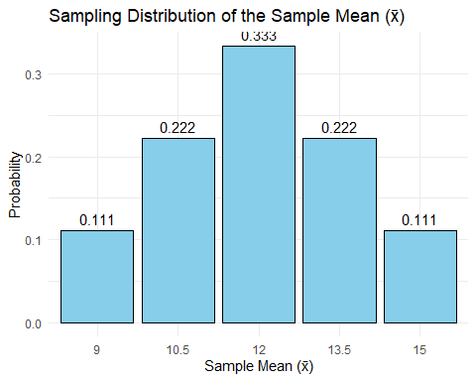

Step-by-Step Explanation of Each Column
- Sample (A, B) – All possible combinations of X values when sampling with replacement (9, 12, 15). There are 9 total combinations (3×3).
- x̄ (Mean) – The mean of each sample. Example: (9,15) ⇒ (9+15)/2 = 12.
- p(x̄) – The probability of each unique mean occurring. Since all combinations are equally likely (1/9 each), p(x̄) = (number of occurrences of x̄)/9.
- x̄ × p(x̄) – Used to compute the expected mean of the sampling distribution.
- x̄² × p(x̄) – Used to compute the variance of the sampling distribution.

Verification
c(mu_X = mu_X, mu_xbar = mu_xbar, var_X = var_X, var_xbar = var_xbar)
## mu_X mu_xbar var_X var_xbar
## 12 12 6 3
We find that:
$μ_{X}=μ_{\overset{‾}{X}}=12$
$σ_{\overset{‾}{X}}^{2}=\frac{σ_{X}^{2}}{2}=3$
Thus, the theory holds true.

Problem 8.21:
population <- c(3, 7, 11, 15)
pop_mean <- mean(population)
pop_sd <- sd(population) # sample SD by default; use population SD instead
pop_sd <- sqrt(mean((population - pop_mean)^2)) # population SD formula
pop_mean; pop_sd
## [1] 9
## [1] 4.472136
samples <- expand.grid(population, population)
sample_means <- rowMeans(samples)
table_means <- as.data.frame(table(sample_means))
table_means$Probability <- table_means$Freq / nrow(samples)
table_means
## sample_means Freq Probability
## 1 3 1 0.0625
## 2 5 2 0.1250
## 3 7 3 0.1875
## 4 9 4 0.2500
## 5 11 3 0.1875
## 6 13 2 0.1250
## 7 15 1 0.0625
mean_sampling <- sum(as.numeric(as.character(table_means$sample_means)) * table_means$Probability)
sd_sampling <- sqrt(sum((as.numeric(as.character(table_means$sample_means)) - mean_sampling)^2 * table_means$Probability))
mean_sampling; sd_sampling
## [1] 9
## [1] 3.162278
theoretical_mean <- pop_mean
theoretical_sd <- pop_sd / sqrt(2)
theoretical_mean; theoretical_sd
## [1] 9
## [1] 3.162278
library(ggplot2)
ggplot(table_means, aes(x = as.numeric(as.character(sample_means)),
y = Probability)) +
geom_col(fill = "skyblue", color = "black") +
geom_text(aes(label = round(Probability, 3)), vjust = -0.5) +
labs(title = "Sampling Distribution of the Sample Mean (x̄)",
x = "Sample Mean (x̄)",
y = "Probability") +
theme_minimal()
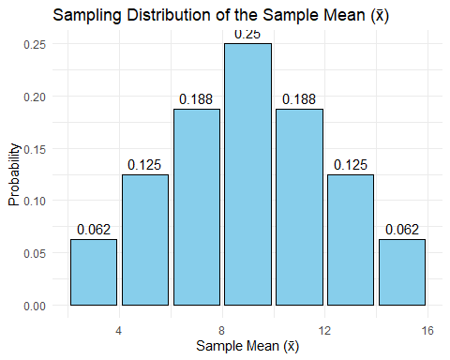
data.frame(
Description = c("Population Mean (μ)",
"Population SD (σ)",
"Mean of Sampling Dist. (μx̄)",
"SD of Sampling Dist. (σx̄)"),
Value = c(pop_mean, pop_sd, mean_sampling, sd_sampling)
)
## Description Value
## 1 Population Mean (μ) 9.000000
## 2 Population SD (σ) 4.472136
## 3 Mean of Sampling Dist. (μx̄) 9.000000
## 4 SD of Sampling Dist. (σx̄) 3.162278

Problem 8.34:
#(a) Probability that less than 40% will be boys
# exact binomial
p_less_80_exact <- pbinom(79, size = 200, prob = 0.5)
p_less_80_exact
## [1] 0.001817474
#(b) Probability that between 43% and 57% will be girls
# exact binomial: P(86 <= X <= 114)
p_between_exact <- pbinom(114, size = 200, prob = 0.5) - pbinom(85, size = 200, prob = 0.5)
p_between_exact
## [1] 0.9599628
#(c) Probability that more than 54% will be boys
# exact binomial: P(X >= 109)
p_more_108_exact <- 1 - pbinom(108, size = 200, prob = 0.5)
p_more_108_exact
## [1] 0.1146233

Problem 8.49:
x <- c(6, 9, 12, 15, 18)
p <- c(0.1, 0.2, 0.4, 0.2, 0.1)
mu <- sum(x * p)
sigma2 <- sum((x - mu)^2 * p)
mu
## [1] 12
sigma2
## [1] 10.8
samples <- expand.grid(x1 = x, x2 = x) # all 25 combinations
samples$mean <- (samples$x1 + samples$x2) / 2
samples$prob <- p[match(samples$x1, x)] * p[match(samples$x2, x)]
head(samples, 10)
## x1 x2 mean prob
## 1 6 6 6.0 0.01
## 2 9 6 7.5 0.02
## 3 12 6 9.0 0.04
## 4 15 6 10.5 0.02
## 5 18 6 12.0 0.01
## 6 6 9 7.5 0.02
## 7 9 9 9.0 0.04
## 8 12 9 10.5 0.08
## 9 15 9 12.0 0.04
## 10 18 9 13.5 0.02
sum(samples$prob)
## [1] 1
knitr::kable(samples, caption = "All 25 samples (with replacement), their means, and probabilities")
All 25 samples (with replacement), their means, and probabilities
x1 | x2 | mean | prob
6 | 6 | 6.0 | 0.01
9 | 6 | 7.5 | 0.02
12 | 6 | 9.0 | 0.04
15 | 6 | 10.5 | 0.02
18 | 6 | 12.0 | 0.01
6 | 9 | 7.5 | 0.02
9 | 9 | 9.0 | 0.04
12 | 9 | 10.5 | 0.08
15 | 9 | 12.0 | 0.04
18 | 9 | 13.5 | 0.02
6 | 12 | 9.0 | 0.04
9 | 12 | 10.5 | 0.08
12 | 12 | 12.0 | 0.16
15 | 12 | 13.5 | 0.08
18 | 12 | 15.0 | 0.04
6 | 15 | 10.5 | 0.02
9 | 15 | 12.0 | 0.04
12 | 15 | 13.5 | 0.08
15 | 15 | 15.0 | 0.04
18 | 15 | 16.5 | 0.02
6 | 18 | 12.0 | 0.01
9 | 18 | 13.5 | 0.02
12 | 18 | 15.0 | 0.04
15 | 18 | 16.5 | 0.02
18 | 18 | 18.0 | 0.01
sampling_dist <- aggregate(prob ~ mean, data = samples, sum)
knitr::kable(sampling_dist, caption = "Sampling Distribution of the Sample Mean")
Sampling Distribution of the Sample Mean
mean | prob
6.0 | 0.01
7.5 | 0.04
9.0 | 0.12
10.5 | 0.20
12.0 | 0.26
13.5 | 0.20
15.0 | 0.12
16.5 | 0.04
18.0 | 0.01
mu_xbar <- sum(sampling_dist$mean * sampling_dist$prob)
var_xbar <- sum((sampling_dist$mean - mu_xbar)^2 * sampling_dist$prob)
mu_xbar
## [1] 12
var_xbar
## [1] 5.4
sigma2 / 2
## [1] 5.4

